**Fundamentals of Management**

**Innovative Research Project**

**On**

**SWOT ANALYSIS ON TESLA**

**Submitted By:**

**SONU KUMAR KUSHWAHA**

**2K19/CO/383**

**TESLA**



**Delhi Technological University**

**Shahabad Daulatpur, Main Bawana Road, Delhi – 110042**

# Information about TESLA

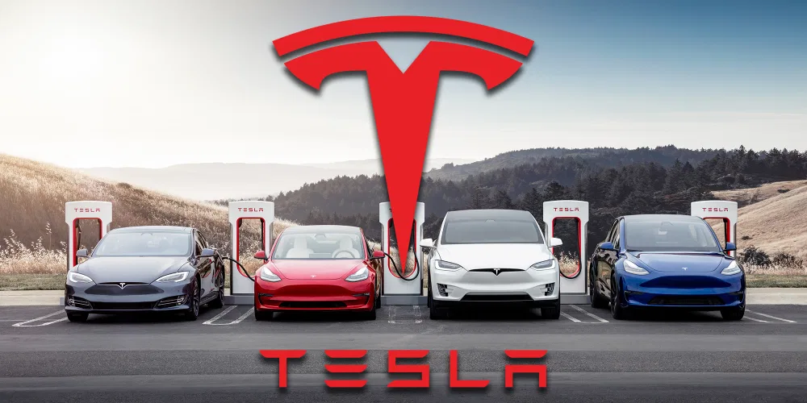

**Tesla** was established in 2003 by a group of engineers who needed to show that driving electric motors doesn't need to be a compromise - they can be much better, quicker, and much more fun to drive than gas vehicles. Tesla now produces not just all-electric cars, but additionally renewable power generating and storage systems which can be infinitely scalable. The quicker the global business moves far from fossil fuels and toward a zero-emission future, Tesla believes, the better**.**

Tesla Motors is a high-performance car that is electric strength space company that designs, grows, creates, and directs the products it makes. To speed the size use of electric vehicles, it's created its own network of vehicle product sales and assistance services, in addition to Recharge stations around the world. It has 208 sites and 585 Supercharger stations in united States, European countries, and Asia at the time of 31, 2015 December. The design S sedan as well as the product X recreation electric vehicle would be the two entirely electric vehicles that Tesla currently creates and offers. Tesla got sent more or less 107,000 new-model S cars globally at the time of December 31, 2015, since the shipment that is initial Summer 2012. Within the 3rd period of 2015, the product X got provided when it comes to very first time. The aim of management will be start producing and shipment associated with new Model 3, which may be a low-cost sedan targeted at the public that is general. Ca, the Netherlands, and a Gigafactory that is future in, Nevada, will be the biggest stores for automobile production. They truly are readily available via many different Tesla storage and events, along with using the internet. In 2015, overall sales is very little over $4 billion, because of the US bookkeeping for 48% of income, Norway for 9%, Asia for 8%, along with other regions bookkeeping for the remaining 8%. Strength storage space items are also offered by this company, like the 7 kWh and 10 kWh Powerwall for residential incorporate while the 100 kWh Powerpack for manufacturing and commercial incorporate. These things happened to be initially offered within the third one-fourth of 2015 beneath the Tesla Energy brand. The organization used 13,058 workers that are full-time of December 31, 2015, and had been situated in Palo Alto, Ca. The organization is made in 2003, as well as its preliminary offering that is publicIPO) occurred on Summer 29, 2010.

# Objective of Study

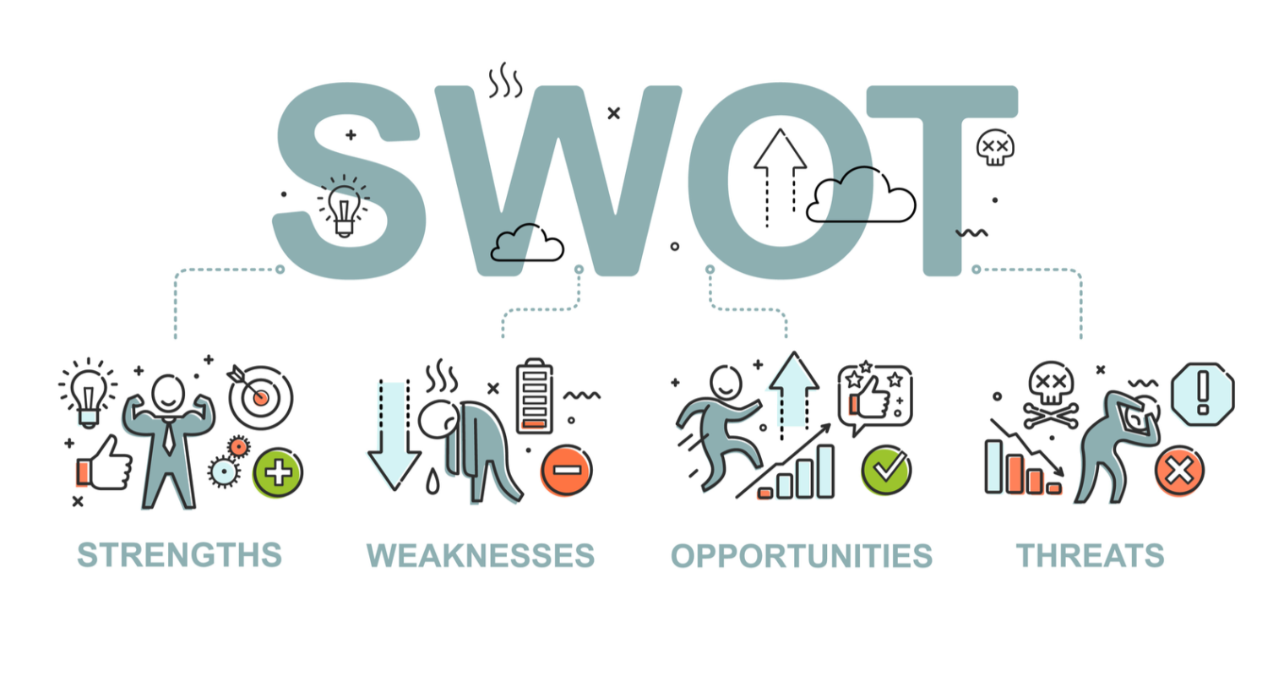

To manage a flourishing providers, company need consider the steps for a frequent foundation to make sure they have been working because properly as you possibly can. While there are many ways to evaluate your business, conducting an analysis that is SWOT among the most profitable. A SWOT review is a preparation tool that might help business overcome obstacles and decide brand new likelihood to pursue. The goal that is fundamental of Swot matrix is always to aid enterprises in building a whole comprehension of most of the aspects which go into choosing a training course of action. This tactic was created when you look at the sixties by Stanford data Institute's Albert Humphrey as an element of a task to find out precisely why companies planning generally unsuccessful. SWOT has grown in appeal since its creation.

# By concentrating on the four aspects of the acronym, businesses might use an analysis that is SWOT to find the forces creating an agenda, task, or project. Businesses which are alert to these positive and features that are bad manage to connect much more efficiently what components of a strategy must be answered. When external risks tend to be coupled with inner weaknesses, the most important challenges that a business confronts may be uncovered. "when you have acknowledged your own dangers," Bauer added, "you can determine whether or not to manage the weakness that is internal allocating providers sources to fix the defects or reduce the external hazard by quitting the threatened sector of companies and working with it when you have bolstered the company."

# You will have to make some ideas and programs based on your findings after you have conducted the analysis that is SWOT created their SWOT platform. In accordance with Linda Pophal, proprietor and President of important marketing and sales Communications, these procedures should give attention to utilizing skills to counter risks and weaknesses.

# Findings

# SWOT Analysis

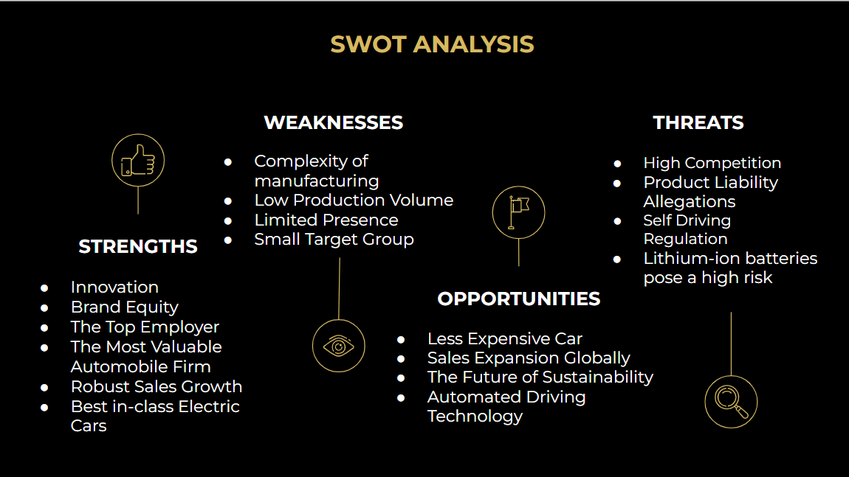

## **Strengths**

Let's start with Tesla Inc.'s strengths, which will range from the positive components of the organization which have bolstered Tesla's position as one of the world's most powerful corporations. Tesla's long-term profitability, expansion, and popularity have been secured because of the following traits, that are thought to be the company's strong points. Tesla, unlike other automakers, isn't primarily focused on automotive sales. Tesla's goal is far bigger: it desires to revolutionize the driving experience. They started by selling electric cars. Tesla is typically the first business that comes to mind if the issue of electric automobiles is brought up, despite the fact that they're not the sole company creating these kinds of vehicles. Unlike other automakers, Tesla has chosen to concentrate on producing low-cost vehicles that are electric.

Tesla has set its sights on a market that is specific: premium electric vehicles. As soon as the firm originally started around 20 years ago, there was no competition in this area. Before anybody else, the founders were able to build out a reputation on their own in this field. It has allowed them to continually retain their supremacy when you look at the sector. Tesla has gained a complete lot of clout and brand power in recent years. Through the previous several years, Tesla has seen growth that is remarkable. Consumers who are interested in the continuing future of electric vehicles as well as the possibility (now reality) of self-driving automobiles might be to be blamed for a lot of this trend. Tesla's expansion is supported by the government, which includes because of the company USD 365 million in funding.

Tesla's energy management activities benefited from the funds. Tesla's success might be attributed in part to timing; the company's operations began during former President Barack Obama's cleantech initiative. The firm managed to obtain government advantages more easily as a result of the. Other companies, notably as Toyota and Mercedes-Benz, have adopted Tesla's cutting-edge technology now that this has achieved such success that is tremendous. This highlights Tesla's status given that automobile industry's market leader.

1. **Innovation:** Tesla the most revolutionary businesses available in the market, compliment of its investment that is continuous in. Tesla has actually a top speed of development (as well as the world’s first electric semi-truck and latest low rider). This confidence and hope offer the team with an important advantage that is financial manufacturing aggressive and lucrative goods. Tesla’s financial in developing newer and technologies that are advanced 2018 was just $1.8 billion, far behind their competition. The business is therefore well-liked by staff eager for the ongoing future of electric vehicle technology. A development improves the company’s popularity and rewards that are financial. Tesla possess a higher speed of creation (not forgetting the entire world's first perfectly semi-truck that is electric newer football car, among others latest advice). The market has faith in the firm and expects it to generate competitive and lucrative goods, which will, in turn, result in significant financial benefits as a result.
2. **Most Valuable Automobile Company**: Tesla's sales profits in fiscal 2021 were $53.8 billion, with 936,172 cars supplied to consumer’s year. The company's marketplace capitalization surpassed compared to the most effective five automakers, attaining $1 trillion (Toyota, Volkswagen, Daimler, Ford, and standard Motor). Tesla has exceeded Toyota due to the fact earth's many automaker market capitalization that is valuable.

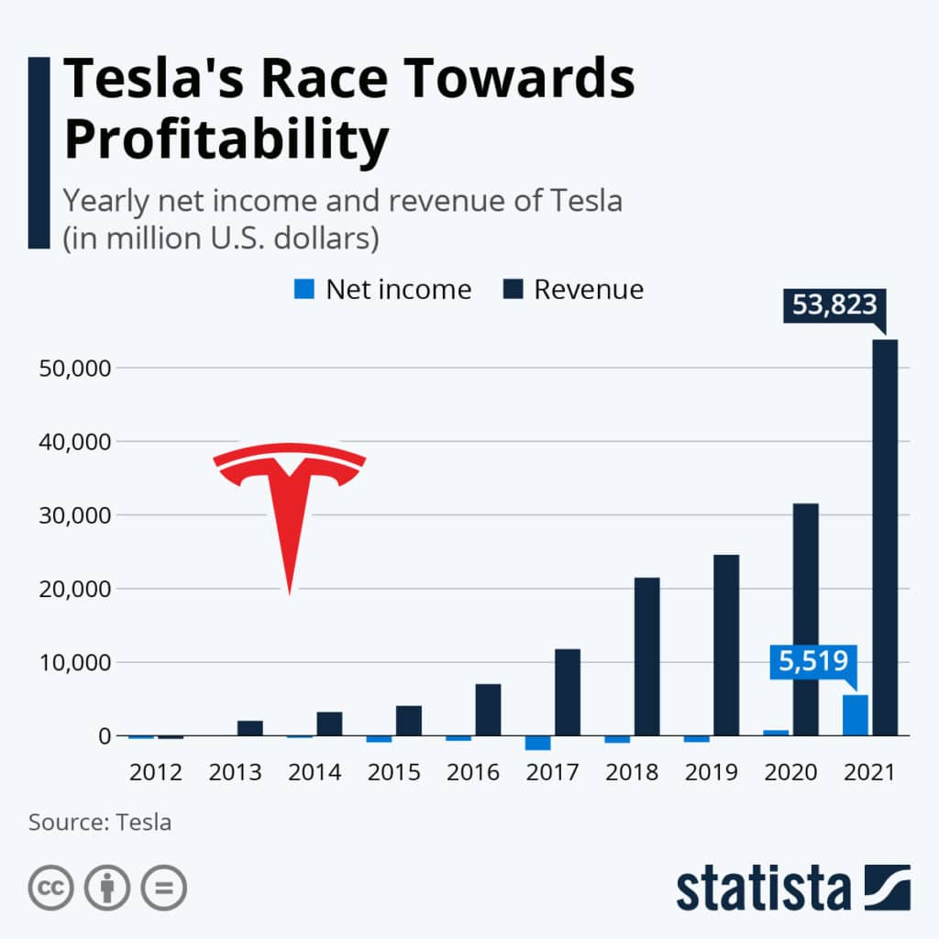

1. **Brand Equity**: Tesla centers on boosting the consumer experiences and goods high quality because it aspires to supply a fantastic driving experience in improvement to producing vehicles. Tesla rapidly turned into the very first term that sprang in your thoughts when anyone mentioned electric vehicles all over the planet, improving brand name equity. Tesla stocks an extremely brand image that is strong. Each time a customer thinks about Tesla they don’t think about an just automobile organization that deal cars. They have a tendency to think of Tesla as a business whose core focus is Innovation and dreams that are turning real life. Tesla isn’t the just automobile business that makes electric automobiles, nonetheless it has developed and reigned over the blissful luxury electric vehicles industry and has now be similar to electric trucks.
2. **Top Employer**: One of many vital aspects of Tesla are the work price. Forbes named the company one of the best areas to the office in 2019. Any business is just as good as the folk that work for this. In the example of Tesla Inc., it really is among the reasons that are primary their extraordinary profits. According to research by the Wall Street Journal, Tesla features emerged as an outstanding staff company due to its varied and revolutionary lifestyle. Tesla is generally accepted as a fantastic firm for younger staff members to pay their ability and energy in since it has actually used a forward thinking and culture that is diverse. It had been lately known as one of the better workplaces, bringing in job that is youthful with new skills and drive. Tesla uses people that are good which will be one of many biggest motorists into the organization's remarkable achievement. Tesla possess appeared as an outstanding company for workers, in line with the Wall road log, compliment of the assortment and innovation-friendly tradition. It absolutely was recently known as one of the best places to get results, bringing in teenagers with latest tactics and interest.
3. **Best in class Electric cars**: Tesla's electric cars have indicated to manage to travelling lengthy ranges. Tesla unit S will need you’re the farthest, with a solitary electric battery charge lasting as much as 600 kilometers. Opel Ampere, which includes a selection of 520 kilometers, could be the competitor that is closest.

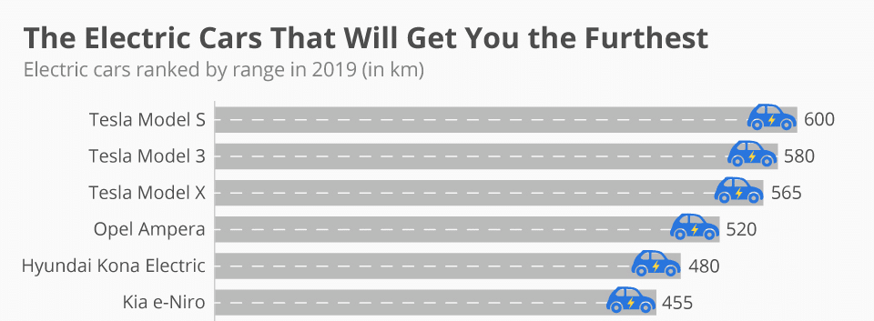

1. **Tesla enjoys skilled sales** that are strong in the past few years, due in large parts to your public's enjoyment for any firm's cars. Adhering to a 59 % growth, the year before, sales enhanced by 27per cent in 2015. This past year, the firm delivered a complete of 936,000 cars, a rise of 87% over 2020 forecasts. In March, the business enterprise reported that it expects product sales to improve by 50% annual, showing that about 1.4 million cars would be sent this current year.

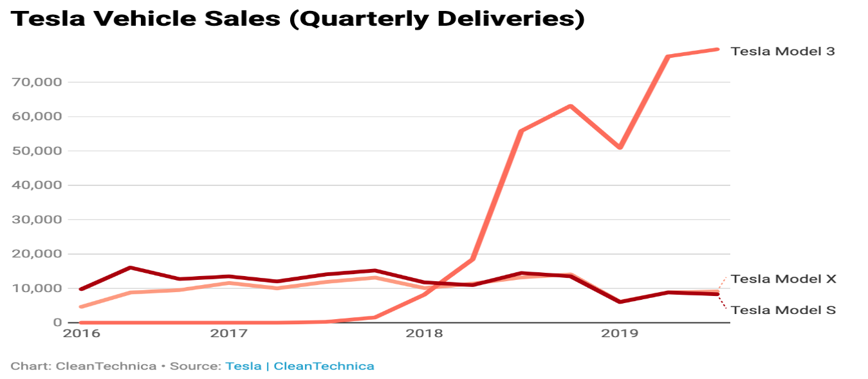

## **Weaknesses**

The SWOT research reveals problems in every right component of a business's inner operations that damage or maximum abilities examination. These are a number of Tesla's business flaws, which hinder the company's competition and progress. Regardless of the huge amount of money given because of the national, Tesla keeps invested an amount that is substantial of in the past few years. Precisely Why? As a result of investments, mostly. Tesla invests greatly on R&D. They may be able only create any such thing fresh in the wonderful world of automobiles through advancement, particularly when you will find simply a few precedents to suck from. Their particular increasing business is also one factor in their cash flow troubles. Tesla's profits increased from $200 million to $6.8 billion in only a few years.

Their unique profits are just $312 million that may seem wonderful. Even yet in 2021, Tesla may continue steadily to spend, spend, and spend. There are the obligations difficulties to think about. As of 2021, Tesla owes $11.6 billion august. Investment leases be the cause of the lion's share of your. The quantity happens to be $920 million. If inventory costs do not develop additionally the company struggles to spend its debt off, the work of a 3rd of Tesla's employees could be imperiled. Tesla uses a fraction of the true amount of people utilized by similar corporations. Previously, they just had one plant, that has been based in Ca. This means that, Tesla will simply be able to develop a restricted amount of autos, making rewarding greater volume objectives more challenging.

1. **Production Difficulty**: Tesla happens to be in a position to take on the entire world's big automobile organizations wearing a period that is short of. The more the amount of creativity, greater the technical difficulties and production threat. Tesla has received a brief history of publish, manufacturing, and ramp-up delays. It has been certainly one of its most pressing dilemmas, since it is not able to reach manufacturing that is high.
2. **Minimal presence**: Although Tesla's yearly revenue is fast increasing; the USA continues to be the company's largest marketplace. In 2018, it made $14.9 billion in sale, with more than 70% of the coming from the United States. With 1.8 billion cash in profits in 2018, the corporation features a strong existence in Asia, but significantly lowers than in the US. Not in the United States and Asia, Tesla's purchases stations is insufficient, hampered by opposition' international submission networking sites.
3. **Low Manufacturing:** Tesla is without a doubt the pioneer of real energy-saving automobiles. However, nothing of the designs have already been in a position to offer in huge numbers. Even now, as Tesla prepares to mass-produce the Model 3 vehicles, it deals with difficulties when it comes to creation prices, managerial information, and area growth at Gigafactory-1.
4. **Elon Musk as Tesla’s main associate**: Tesla allows that the business is a ‘one-man program.’ Unfortunately, that man, Elon Musk includes a complete good deal on his arms to provide their hundred % into the business. Musk can be significantly tangled up in more works like room introduction motors at area research Technologies business in addition to bland team.
5. **Target audience**: Tesla's goal would be to provide premium products to a tiny market while maintaining reasonably limited automobile image that is corporate. The market is small, making expansion difficult because of the high product prices. Despite its price that is reducer’s Model 3 appeals to a wider audience, yet it still only reaches only a few individuals.
6. **Electric batteries scarcity with no Profits coming soon**: During the business's yearly shareholder meetings, Musk, the CEO, revealed that manufacturing got slowed because of a shortage of battery packs. The paucity of electric motors and energy space devices experienced a influence that is direct deals. Due to the highest running expenditures and manufacturing that is limited, Tesla happens to be using up earnings without making an income. The organization owing $2.5 billion in 2016. The business's incapacity to cease money that is losing an adverse impact on buyer belief and show prices.

## 

## **Opportunities**

This SWOT overview' potential section is directed from the business's brand new increases people. It's a aspect this is certainly party that is 3rd if uncovered, may help Tesla promote its industrial efficiency, government structure, proper development, and also other items. Tesla's spending should be reduced before maybe it's successful. To function with this, the continuing company is now generating Giga plants. Giga generation places can enhance vehicle support and manufacturing companies achieve their particular objectives. The corporation could perhaps take advantage of bulk purchasing goods discounts due to its capacity to establish in huge amounts. For quite a while, Tesla created almost all its motors in a distinct segment webpages that will be Fremont that is solitary. For any company, two Giga facilities that are industrial now started done. The 3rd was booked be finished in May in the, triggering a complete of three one year.

They truly are design vehicles which happen to be decreased damaging to environmental surroundings. What considerably could environmentally minded drivers inquire about? Tesla's commitment to durability was admirable, and it's also among the major causes for the recognition. It, having said that, distorts the business's vision. Whenever will they have the ability to illustrate self-driving trucks? Can clients faith the business to perform these goals that are ambitious? Are these days a better time for you to spend, regardless of the cost that is high? Tesla may be the one that is only knows the responses to those issues. It really is copied because of the organizations term, brand name profile, and influence. Tesla is really the only carmaker with all the capacity to boost ecofriendly and sustainable driving.

More affordable automobiles: Tesla is high priced owing of its unusual focus on advancement, which necessitates much investment to test out new technologies. The design 3, a much less listed variant for the unit S with fewer number, electricity, and facilities, ended up being merely introduced by Tesla. Tesla, in contrast, includes remarkable potential to broaden their unique marketplace.

1. **Deals development globally**: the 2 vehicle markets that are largest on the planet, the USA and Asia, account for nearly all Tesla sale. Nonetheless, even though the United States of America taken into account 70% of Tesla selling, Asia added $1.8 billion in general profit in 2018, bookkeeping at under 10% of total purchases. Asia is homes to your planet's fastest-growing economic climates. Concentrating much more about parts of Asia, notably Asia and India, will considerably help Tesla build Giga selling and create by itself like a commander on the market. The market that is Asian which can be presently underserved into the automobile and renewable power sectors, provides the business's most crucial potential today, especially considering Tesla's aspire to increase its global markets so that you can augment their financial balance and industry presence.
2. **Future of durability**: throughout the change from traditional fuels to energy that is sustainable interest in lasting services and products skyrocketed. Tesla is just one of the few corporations this is certainly establishing renewable energy and electric vehicle merchandise. Because of this, need for their goods and options try growing every day, therefore the organizations business are increasing at the same time.
3. **Automated technology** that is driving Tesla's autopilot technologies is viewed as one of the more successful programs in terms of revealing security and benefits around the world. This kind of technologies was substantial sufficient when you look at the vehicle companies to be looked at a change. The electric automobile produced by the business enterprise has lots of potential for the future of autos.
4. **Introduction of pick-up truck**: in accordance with National Automobile provider connection share of the market facts, Pick-up truck makes up 17.6 % for the United States market that is automotive that has huge options of development in Electrical Vehicle. Cyber vehicle can bring a complete large amount of gains options for Tesla within this phase.

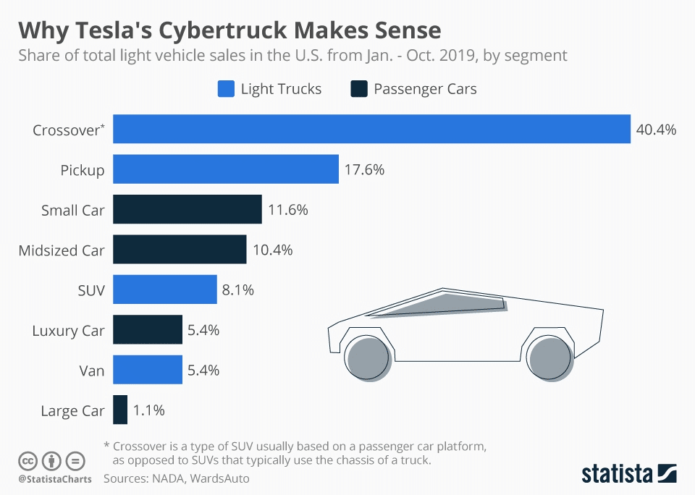

## **Threats**

The chance factors were paired with phenomena that hinder the company from completely using their resources that are available. Because of this, Tesla confronts a restricted wide range of dangers to be able to continue functioning regardless of the market that is volatile. Despite the fact that Toyota tends to make cars with a certain market, they competes along with other corporations such as for example Toyota, Ford, and Bing. The majority of other car manufacturers create low-cost electric and hybrid automobiles for the general public. It doesn't rule the chance out which they may fundamentally change to higher-end deluxe automobiles. The corporation may face direct competition from other well-known automakers if it begins producing lower-cost vehicles. Loans could be the business's other threat that is major. Tesla's inventory keeps plummeted in worth since that time, yet it stays a cloud. Unique technical improvements and the building of bigger manufacturing products might have to become delayed until more see. If Tesla preserves doing this, its future profitability will become significantly damaged.

1. **Opposition**: Despite Tesla's reputation being an electric automobile pioneer, its rivals, many of which have been around in the field for years and years, have rapidly swept up with electric automobile innovation. Moreover, their particular more affordable cost may into the future attraction Tesla purchasers. The actual fact that Tesla seems to function as the best team producing top-quality vehicles, other organizations may heed match, setting Tesla in an exceedingly position that is competitive. A lot of companies include unveiling or likely to present ecofriendly/self-driving systems, because of the goal of promoting it in a discounted price. It is an obvious problems for an organization like Tesla, which utilizes its distinctive worth for brand new trucks that are exorbitantly cost and beyond of go for most people.
2. **Product responsibility accusations**: Tesla is worried that product responsibility litigation will likely be among the company's more significant financial setbacks. Tesla possess delivered a true number of self-driving automobiles, although not them all have proven to be secure in a major accident. A few lawsuits have now been brought up against the business. Despite Tesla's superior quality confidence and creation criteria, the vehicle sector, in specific, is employed to handling major items liability lawsuits, that the businesses thinks is supposed to be one of many firm's worst economic blows. Tesla possess introduced a true quantity of autopilot vehicles, not them all are actually safe in the case of a major accident. Litigation and boasts have now been recorded contrary to the agency because of failures that are technological its merchandise. If these obligation litigation persist, Tesla may face a lot more financial difficulties.
3. 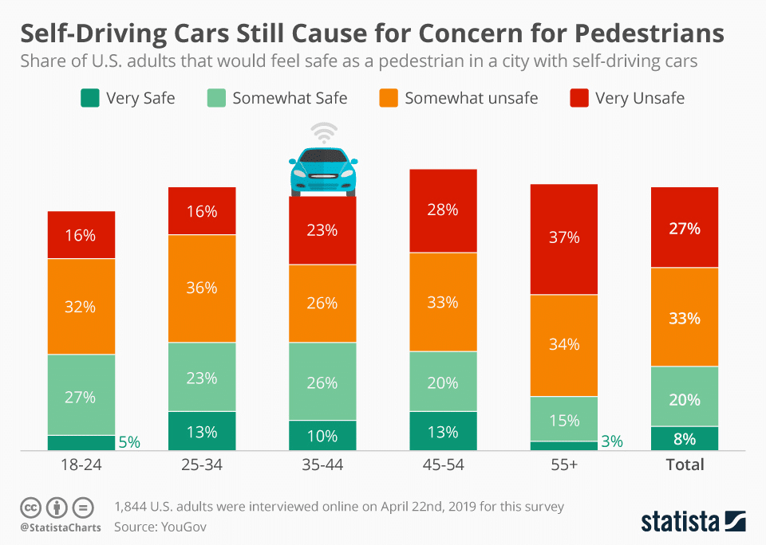**Self-driving laws**: Tesla has invested dramatically in autopilot technology, but no nation, such as the United States of America, enjoys proper rules to control self-driving trucks. Tesla's future try jeopardized from this snafu that is legal along with some people's incapacity to purchase a Tesla. In a survey from YouGov, US adults still feel dangerous simply to walk around self-driving autos. Specifically, visitors above the chronological age of 55 will be the most scared to get around self-driving motors.

# Lithium-ion battery pack presents high-risk: Tesla's power packs are made of lithium-ion tissues. Because lithium are a very activated and explosive aspect, our products have a greater chances factor. Tesla has already established a couple of incidents where their own autos need caught fire and emitted smoke that has severely tarnished the organization.

# Conclusion

Tesla is a pioneer that is well-known the sphere of durability and innovation. Tesla provides the skills to keep to reach your goals, in line with the SWOT analysis. Specific troubles could be experienced because of the organization.

International expansion in Asia as well as other areas of the global world is especially vital. Tesla needs to rethink the methods while focusing on growing their global popularity.

Tesla is really a vehicle that is progressive this is certainly determined to improve the facial skin of driving as time goes on. They may not be just focused on making elegant, eco-friendly automobiles when it comes to affluent but additionally on generating progress in independent driving.

This analysis that is SWOT all of Tesla’s markets skills, weak points, ventures, and risks. Tesla must take decisive action to improve their share of the market and financial security.

# According to the analysis that is SWOT Tesla must –

* Manage and increase study into alternate sources of energy.
* Work with strengthening buyers trust and confidence that is long-term the corporation.
* Stretch their get to internationally and attempt to protect international creation.

# References

1. <https://bstrategyhub.com/tesla-swot-analysis/>
2. <https://iide.co/case-studies/swot-analysis-of-tesla/>
3. <https://www.tesla.com/>
4. <https://seoaves.com/tesla-swot-analysis/>
5. Mintel. “Marketing to Generation X - U.S.” June. 2016. Mintel. UGA Library, Athens, GA. 22 Oct. 2019.

“Tesla Model 3 Case Study.” Media Flight Plan, https://mediaﬂightplan.com/.

1. Alvarez, Simon. “Tesla Spends $0 on Ads, Still Tops Automakers in Organic Engagement: Report.” TESLARATI, 7 May 2019, www.teslarati.com/tesla-advertising-organic-social-media-engagement/.